Data Visualization and Analysis
Dominick Campbell
October 31, 2025
CIS480 32778
Dr. Kashihara

Hypothesis Overview and Connection
This project aimed to explore the relationship between the median single earner and the ability to purchase a home with regards to current house pricing. Further, it also aimed to explore and show what kind of home they might be able to purchase. In addition to this, this project also evaluated the relationship between population density and home pricing by examining the affect of population density on the price of a home and if it was of any real importance. As such, the project aimed to examine the following two hypotheses, both of which being a 1 tailed test. Null Hypothesis 1: Population density contributes strongly to residential home value in Maricopa County. Alternate Hypothesis 1: Population Density has no statistical significance on residential home pricing in Maricopa County. Null Hypothesis 2: Single income median earners have insufficient income to purchase residential homes in Maricopa County. Alternate Hypothesis 2: Single income median earners have sufficient income to purchase residential homes in Maricopa County.
With this in mind, we can discuss the features that were available for collection as well as what charts this project will aim to provide the end user for viewing and understanding the conclusions of the data. Features of the data in this project included Zip Code, City, Home Type, Population Density, Median Home pricing data by month, and Income per Capita. While other categorical features of the homes would have been useful and would have improved the data quality of the dataset as a whole, such data was not publicly available in a way that would have been useable for this project. As a result, these are the features that were utilized to evaluate the above hypothesis. Charts for this project will include the following type with intentions to visualize information regarding the hypothesis as well as evaluation of the machine learning models created for this project. Let us first start with the machine learning model chart:
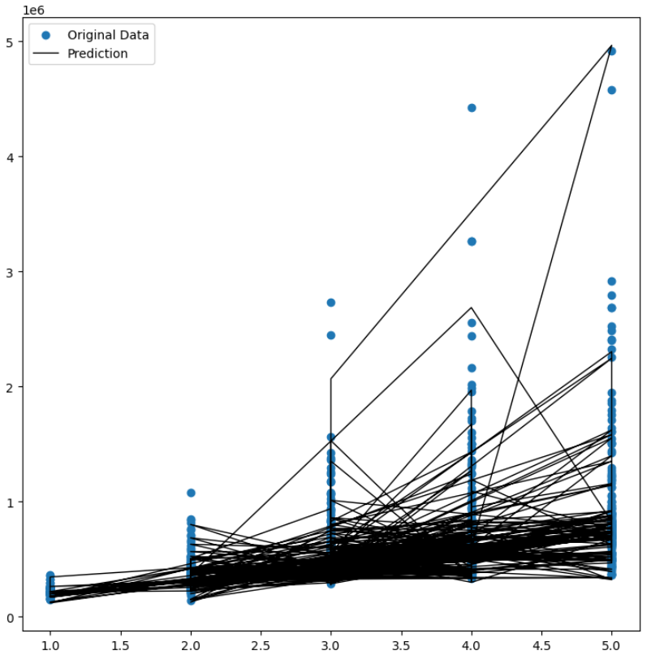
This was a prediction graph created from the Lasso regression model attempting to predict pricing based on the original data vs the predicted data. R2 value for this model was 0.98, showing that the data for the this is almost positively overfit. However, other categorical factors did not have enough of a representation to create a model with statistical significance, with the maximum R2 score being ~0.22 with all other features beside pricing data from 01/31/2020 included and a graph of the model for this is below.
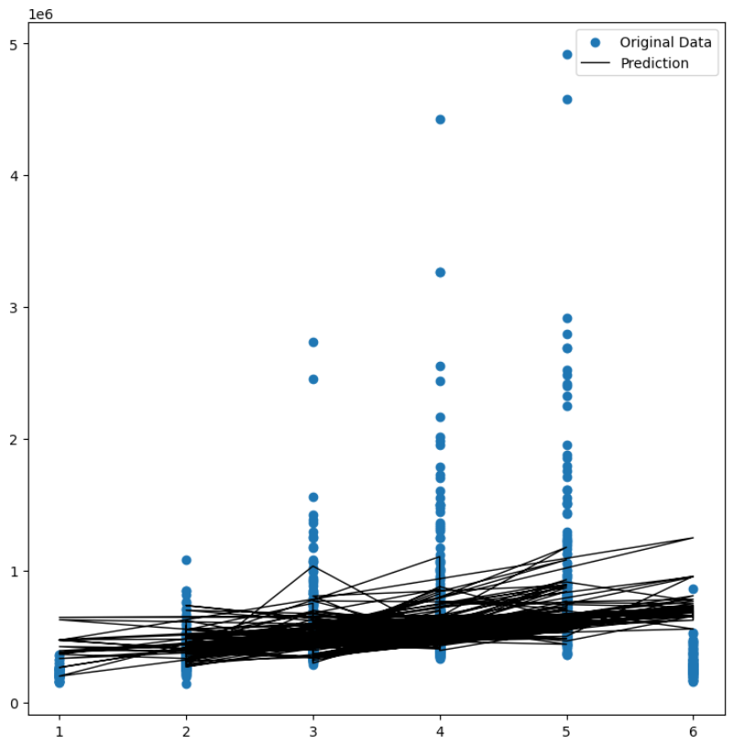
Further analysis with only population density data reveals an R2 value of 0.0142, showing a statistically insignificant value for the model, as shown by the prediction graph below:
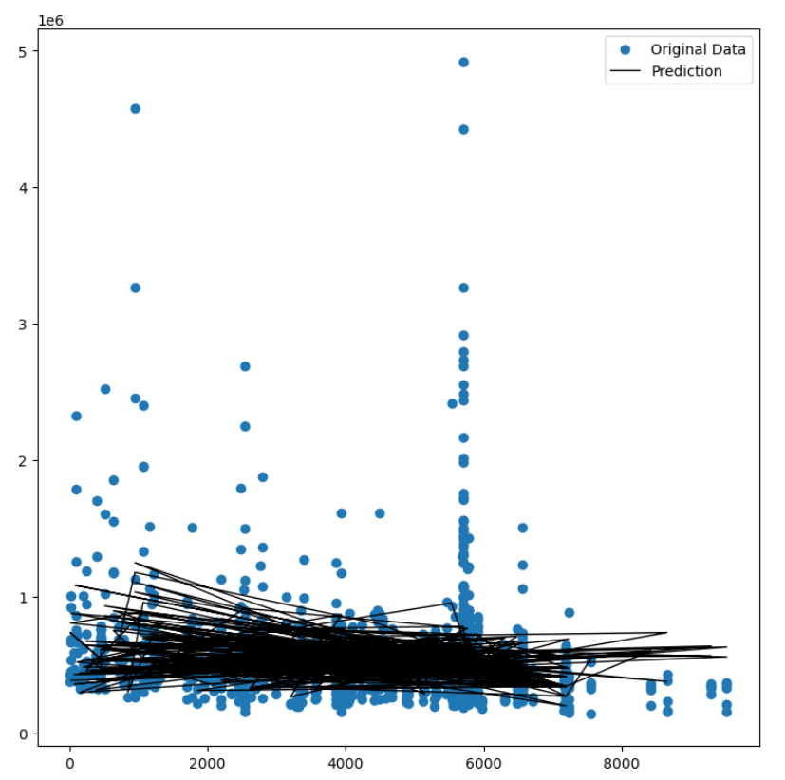
Further to answer the second question, this project aimed to have a decision tree categorical model for categorizing the Maricopa County market by housing price data represented as Monthly Mortgage Payments by the different types of residences. The chart below shows the categorical model’s representation of this:
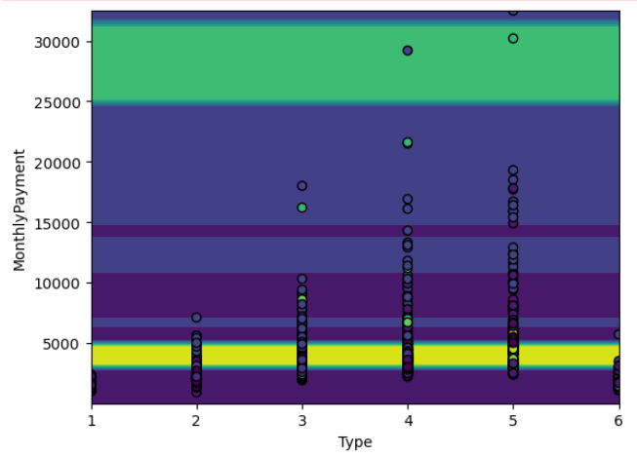
The first chart this project aims to utilize will be a pie graph showing the count of values within the dataset that made up homes based on the slicer settings and user input filtered by city and monthly payment:
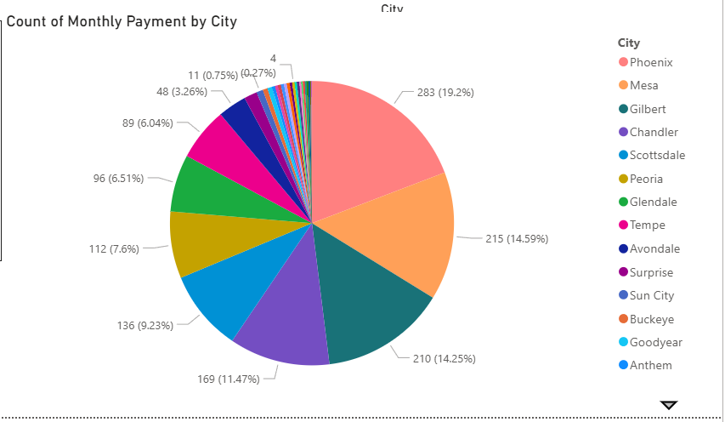
The second chart intended for this project is a bar chart that breaks down the monthly payments by the type of residence:
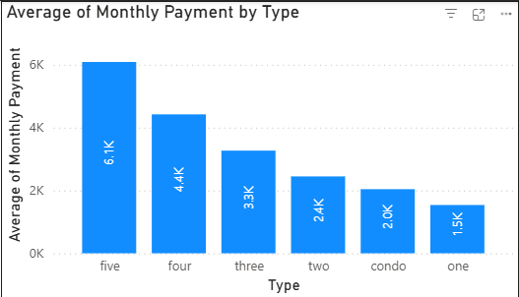
The third chart aims to explore the information related to the average price of homes by per capita income and is filtered and broken down by the city information. This allows us to examine the affect of per capita income on the housing market as well as see where outliers exist that may be worth looking into.
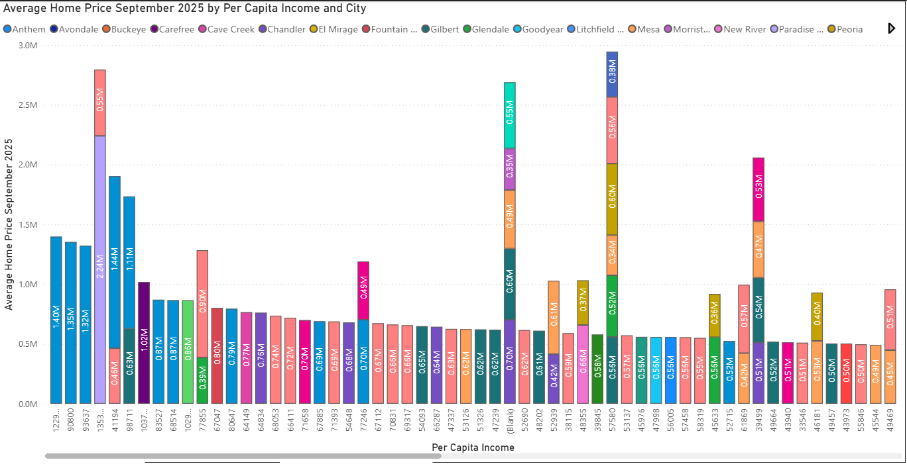
The next chart is a population density chart showing population density compared to house pricing for Maricopa County. This chart aims to show the above mentioned population density mismatch found when doing the machine learning model creation and answer directly one of the hypotheses. The following chart is an example of what this will look like though it still needs some refinement
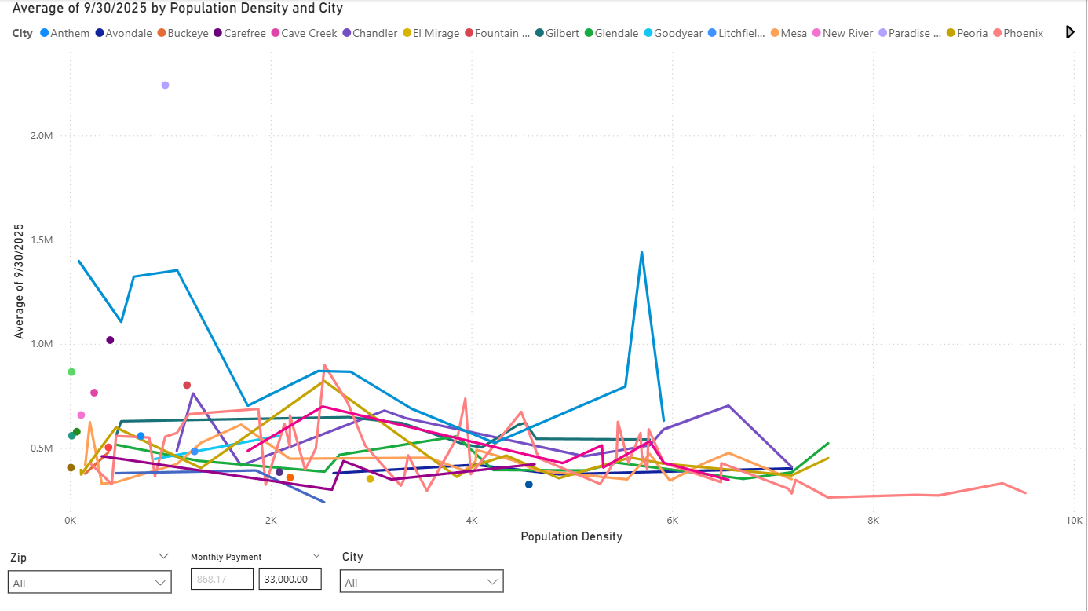
The final group of charts that this project will aim to present will be a side by side set of bar charts showing the average per capita income maximum monthly payment amount as defined by no more than 50% of take-home income to be utilized for a mortgage payment. In essence, average per capita income divided by 12 (now monthly income), divided by 2 to become the maximum allowable mortgage payment determined by zip code. Next to a bar chart showing the average monthly payment determined by the mortgage calculation with a credit score between 700-760 and an interest rate from 10/23/2025, by zip code. Both charts will have a city legend to ensure that any zip code traversing multiple cities will show the information about both.
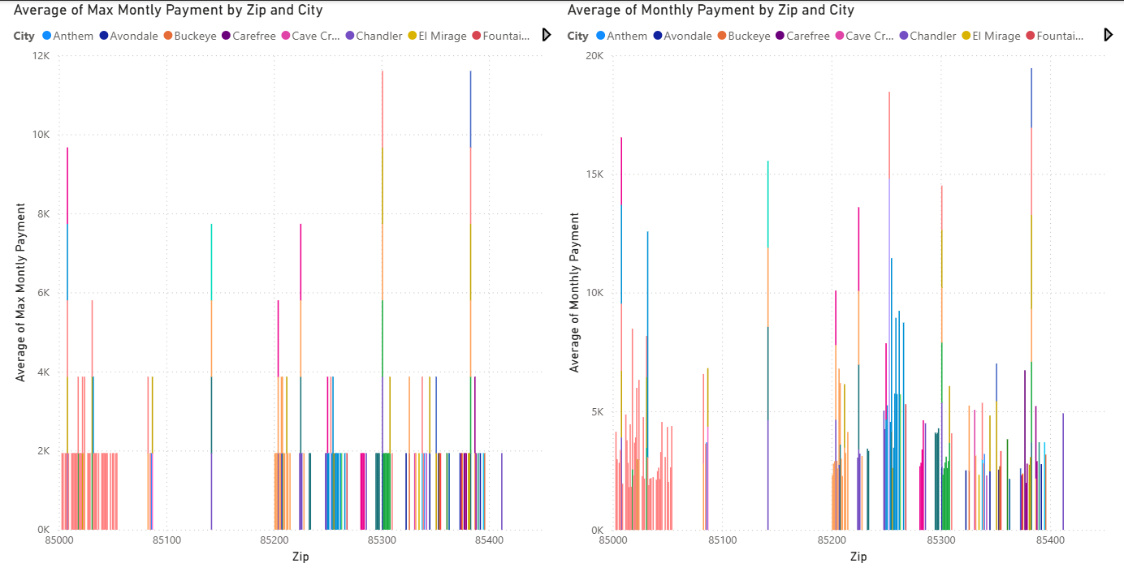
Lastly, the report aims to have 3 slicers that are synced across all report pages to ensure ease of use and readability. The slicers will be made up of 3 different features. The first feature being zip codes, the second being monthly payment, and the last being city. This allows for analysis of more granular levels of data, allowing the end user to see data more clearly as broader views of the charts are mostly unusable, but become important as the data becomes more granular.
